**Lesson08 Working with Object interface**

**1-you can make interface / class and use it as property on the main class**

import { Component, OnInit } from '@angular/core';

@Component({

selector: 'app-my-component',

templateUrl: './my-component.component.html',

styleUrls: ['./my-component.component.css']

})

export class MyComponentComponent implements OnInit {

emp:Employee;

emplst:Employee[];

constructor()

{

//we make initialize of the object of type Employee

this.emp =

{

Fname:"Mohammed",

Lname:"Nabil",

Age:23,

IsExist:true

}

//we make initialize of the object of type Employee[]

this.emplst =

[

{

Fname:"Yosef",

Lname:"Ahmed",

Age:27,

IsExist:true

},

{

Fname:"Talal",

Lname:"Ahmed",

Age:30,

IsExist:false,

},

{

Fname:"Riyad",

Lname:"Isam",

Age:42,

IsExist:true

}]}

ngOnInit() {}}

interface Employee{

Fname:string;

Lname:string;

Age:number;

IsExist:boolean;}

**Lesson 09 Make Export and Import expression**

**1-create folder called Business under the Components**

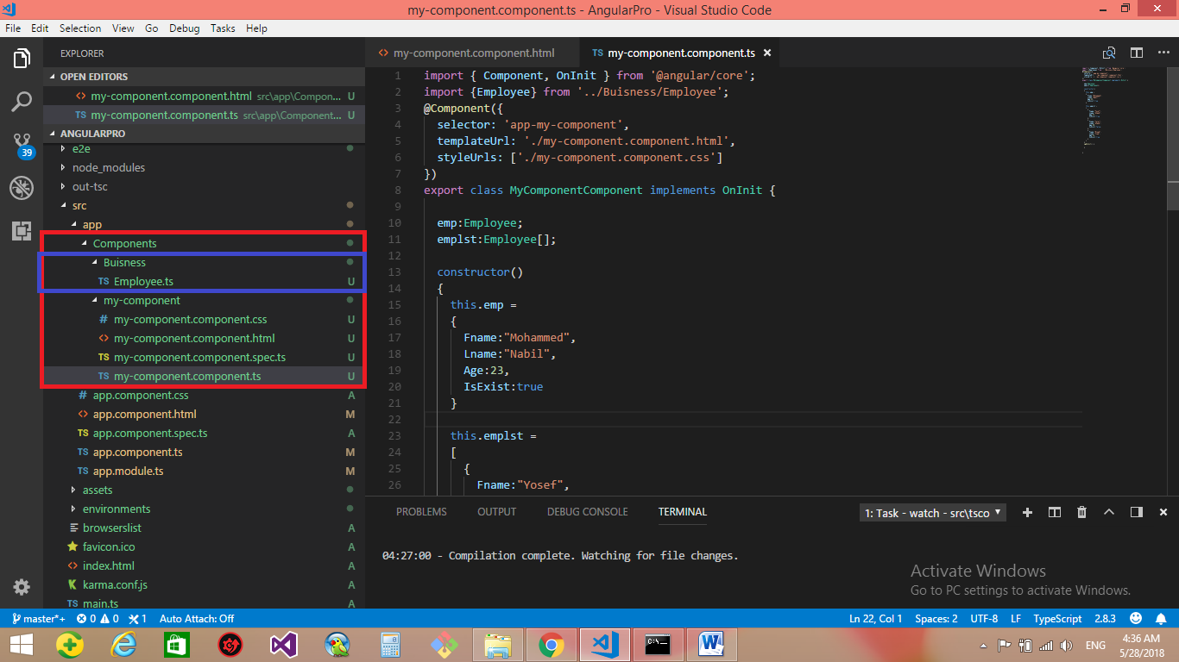

**2-on the Employee.ts**

//we write export the type

export {Employee}

interface Employee{

Fname:string;

Lname:string;

Age:number;

IsExist:boolean;}

**3-on the my-component.component.ts make the import expression**

import { Component, OnInit } from '@angular/core';

//we import the type on the my-component.component.ts

import {Employee} from '../Buisness/Employee';

@Component({

selector: 'app-my-component',

templateUrl: './my-component.component.html',

styleUrls: ['./my-component.component.css']

})

export class MyComponentComponent implements OnInit {

emp:Employee;

emplst:Employee[];

constructor() {

this.emp = {

Fname:"Mohammed",

Lname:"Nabil",

Age:23,

IsExist:true}

this.emplst = [{

Fname:"Yosef",

Lname:"Ahmed",

Age:27,

IsExist:true

},{

Fname:"Talal",

Lname:"Ahmed",

Age:30,

IsExist:false,

},{

Fname:"Riyad",

Lname:"Isam",

Age:42,

IsExist:true

}]}

ngOnInit() {

}

}

**4-on the cmd retype the command ng serve , to recompile the project**